**CP Club 365Days Challenge**

**Date – 22/11/2022**

**Programming language – only C language**

**Problem Statement**

**Code must be in C language only**

<https://www.hackerrank.com/challenges/ctci-array-left-rotation/problem?isFullScreen=true&h_l=interview&playlist_slugs%5B%5D=interview-preparation-kit&playlist_slugs%5B%5D=arrays>

**Your Code**:

// 0x36Day of 0x365Days challenge

// VEDANT BHARAD

// 22-11-2022

#include <assert.h>

#include <ctype.h>

#include <limits.h>

#include <math.h>

#include <stdbool.h>

#include <stddef.h>

#include <stdint.h>

#include <stdio.h>

#include <stdlib.h>

#include <string.h>

char* readline();

char* ltrim(char*);

char* rtrim(char*);

char** split_string(char*);

int parse_int(char*);

int* rotLeft(int a_count, int* a, int d, int* result_count) {

    *result_count=a_count;

    for(int loop = 0; loop < d; loop++)

    {

        int temp =a[0];

        for(int loop2 = 0; loop2 < (a_count-1); loop2++){

            a[loop2]=a[loop2+1];

        }

        a[a_count-1]=temp;

    }

    return a;

}

int main()

{

    FILE* fptr = fopen(getenv("OUTPUT_PATH"), "w");

    char** first_multiple_input = split_string(rtrim(readline()));

    int n = parse_int(*(first_multiple_input + 0));

    int d = parse_int(*(first_multiple_input + 1));

    char** a_temp = split_string(rtrim(readline()));

    int* a = malloc(n * sizeof(int));

    for (int i = 0; i < n; i++) {

        int a_item = parse_int(*(a_temp + i));

        *(a + i) = a_item;}

    int result_count;

    int* result = rotLeft(n, a, d, &result_count);

    for (int i = 0; i < result_count; i++) {

        fprintf(fptr, "%d", *(result + i));

        // printf("%d", *(result + i));

        if (i != result_count - 1) {

            fprintf(fptr, " ");

            // printf(" ");}

    }

    fprintf(fptr, "\n");

    fclose(fptr);

    return 0;

}

char* readline() {

    size_t alloc_length = 1024;

    size_t data_length = 0;

    char* data = malloc(alloc_length);

    while (true) {

        char* cursor = data + data_length;

        char* line = fgets(cursor, alloc_length - data_length, stdin);

        if (!line) {

            break;}

        data_length += strlen(cursor);

        if (data_length < alloc_length - 1 || data[data_length - 1] == '\n') {

            break;}

        alloc_length <<= 1;

        data = realloc(data, alloc_length);

        if (!data) {

            data = '\0';

            break;}

    }

    if (data[data_length - 1] == '\n') {

        data[data_length - 1] = '\0';

        data = realloc(data, data_length);

        if (!data) {

            data = '\0';}

    } else {

        data = realloc(data, data_length + 1);

        if (!data) {

            data = '\0';

        } else {

            data[data_length] = '\0';

        }

    }

    return data;

}

char* ltrim(char* str) {

    if (!str) {

        return '\0';}

    if (!*str) {

        return str;}

    while (*str != '\0' && isspace(*str)) {

        str++;}

    return str;

}

char* rtrim(char* str) {

    if (!str) {

        return '\0';

    }

    if (!*str) {

        return str;

    }

    char* end = str + strlen(str) - 1;

    while (end >= str && isspace(*end)) {

        end--;

    }

    *(end + 1) = '\0';

    return str;

}

char** split_string(char* str) {

    char** splits = NULL;

    char* token = strtok(str, " ");

    int spaces = 0;

    while (token) {

        splits = realloc(splits, sizeof(char*) * ++spaces);

        if (!splits) {

            return splits;

        }

        splits[spaces - 1] = token;

        token = strtok(NULL, " ");

    }

    return splits;

}

int parse_int(char* str) {

    char* endptr;

    int value = strtol(str, &endptr, 10);

    if (endptr == str || *endptr != '\0') {

        exit(EXIT_FAILURE);

    }

    return value;

}

**Output (Screen Shot)**:

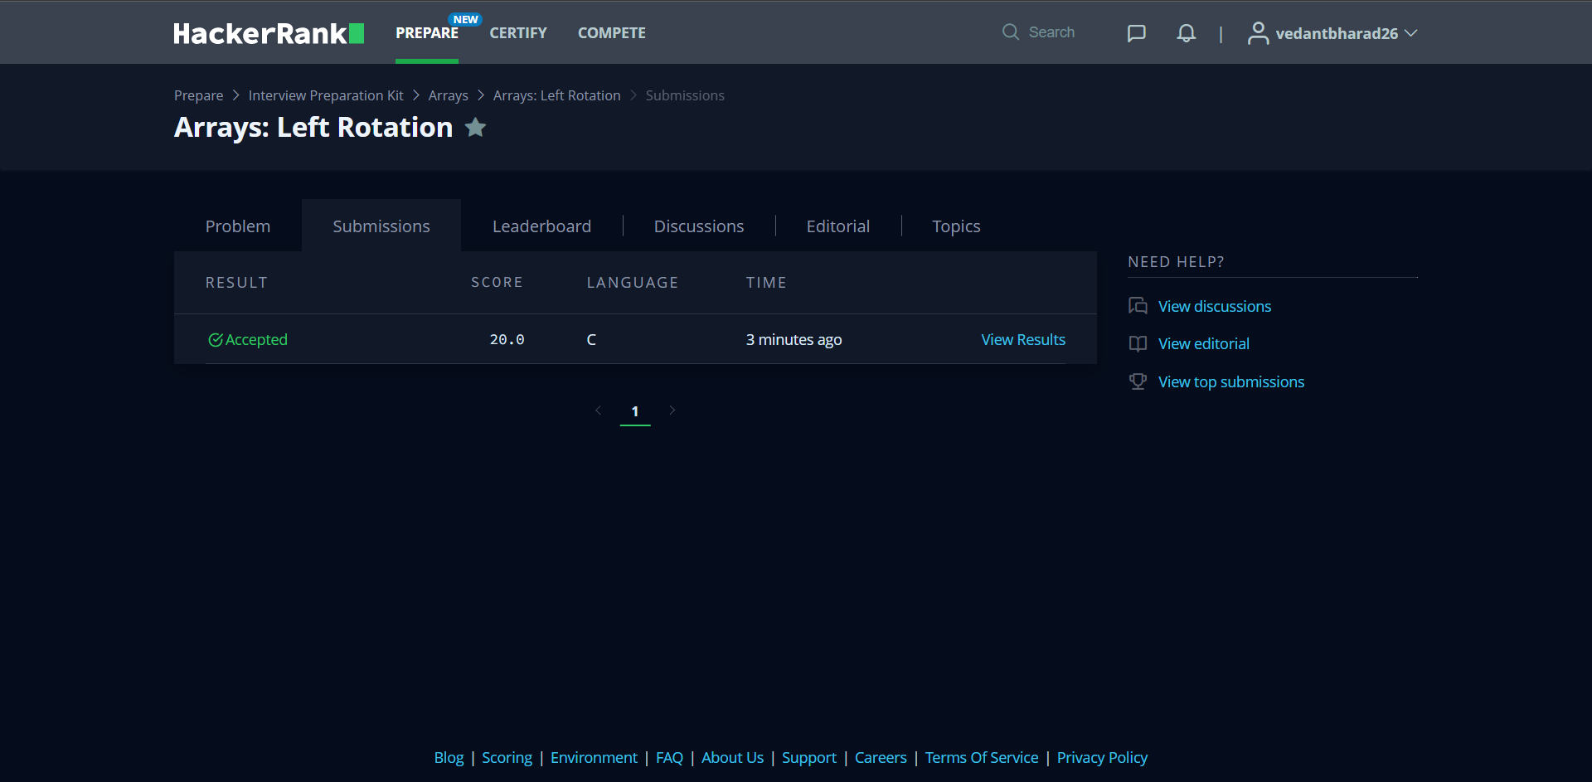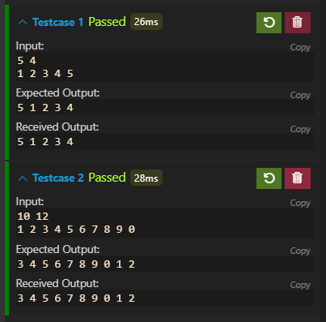

**Understanding about problem:**

* In this task there is three inputs

1. Length of array
2. N time Left Rotation
3. Array it self

* In this task I need to do Left Rotation of array and return that.

Note: If you can't understand the problem, feel free to contact us and we'll help you. Please don't copy and paste from anywhere.

ALL THE BEST

Team CP Club